Why DNN more Accurate?

While a Machine Learning model makes decisions according to what it has learned from the data, a Deep Neural Network (DNN) arranges algorithms in a fashion that it can make accurate decisions by itself. Thus, although Machine Learning models can learn from data, in the initial stages, they may require some human intervention. But, in DNN human intervention is not needed. As a result DNN able to learn the features which are even not predictable by humankind. Hence, DNN yield high accuracy compared to other existing models.

**DNN Formula** - a k = σ ( ∑ j a j w j k + b k ) , with the neuron activation, ( a j ) j the activations from the previous layer, and w j k , b k the weight and bias parameters of the neuron.

$$a_{k}=σ\left(Σ_{j}a_{j}ω_{jk}+b_{k}\right)$$

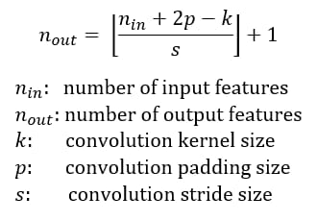

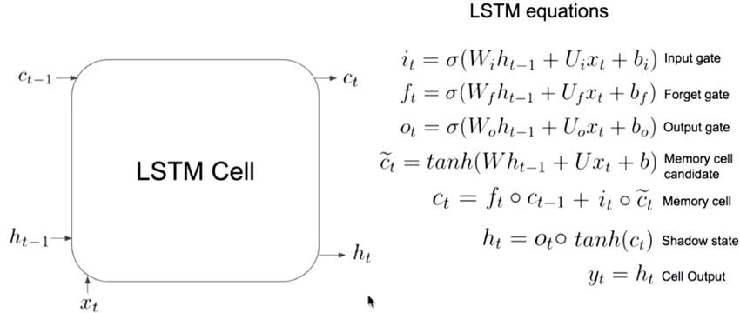

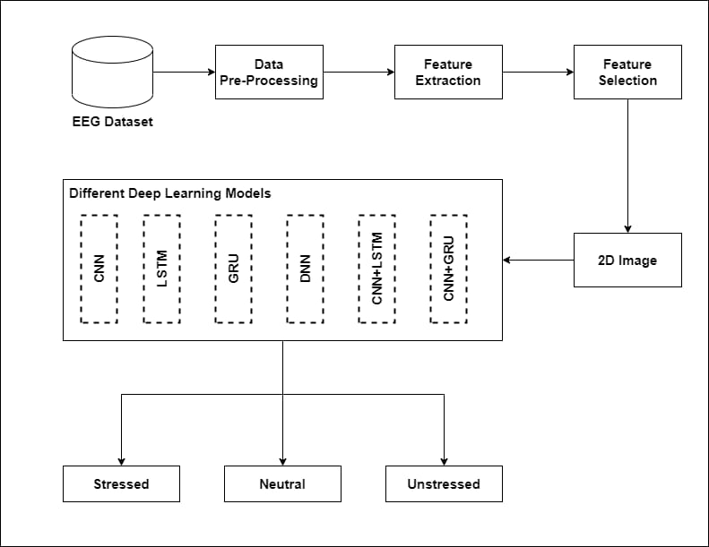

**Table 1: Existing Works with Machine Learning**

**Models and its accuracy**

|  |  |  |
| --- | --- | --- |
| **Existing Works** | **ML/DL Models** | **Accuracy (%)** |
| Avik Sarkar et al., [5] | RNN | **96.50** |
| L. Malviya et al., [6] | Random Forest | 78.6 |
| P. D. Purnamasari et al., [7] | KNN | 80 |
| A. A. Rahman et al., [8] | SVM | 95.36 |
| R. K. Jeevan et al., [9] | LSTM | 64.36 |
| P. Nagar et al., [10] | KNN | 74.43 |

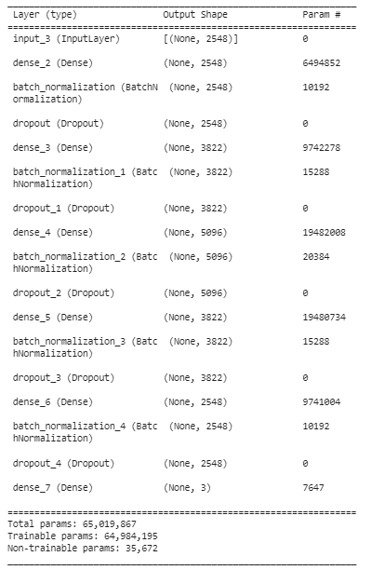

**Figure 8: Proposed Architecture of DNN Layers**

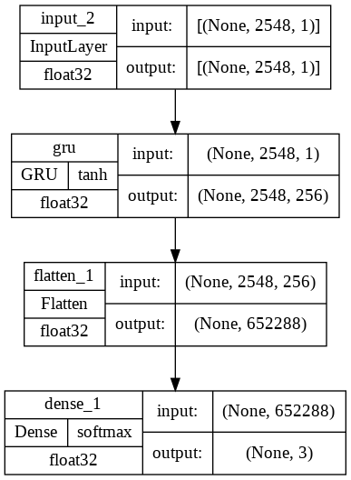

**Figure 7 : Proposed GRU Layer Architecture**

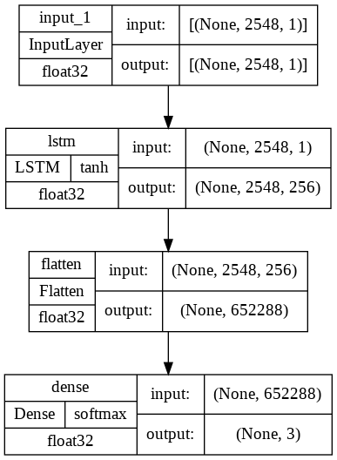

**Figure 6 : Proposed LSTM Layer Architecture**

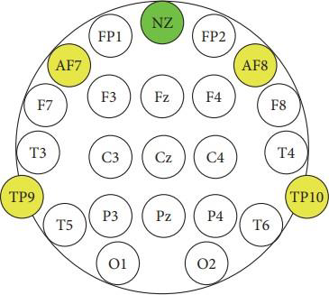

Figure 3 : EEG sensors TP9, AF7, AF8, and TP10

of the Muse headband on the international standard

**EEG placement system**

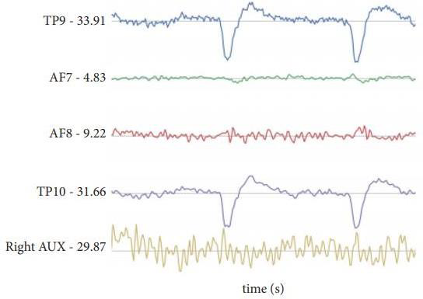

**Figure 4 : An example of the raw data retrieved from the headband**

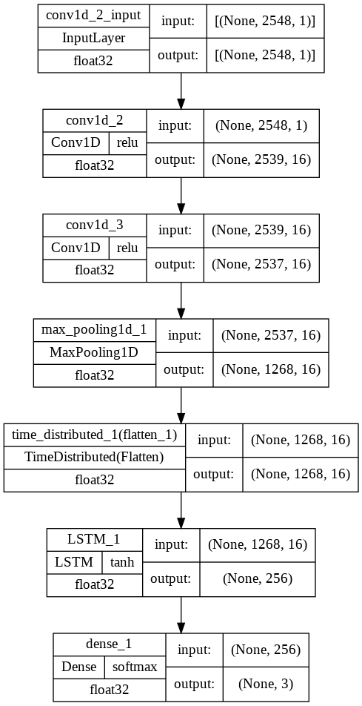

**Figure 9: Proposed Architecture of CNN+LSTM Layers**

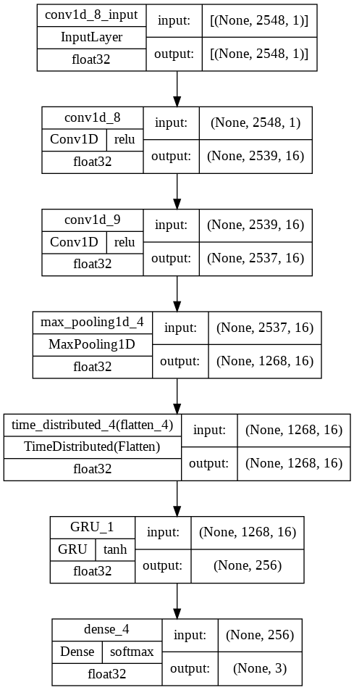

**Figure 10: Proposed Architecture of CNN+GRU Layers**

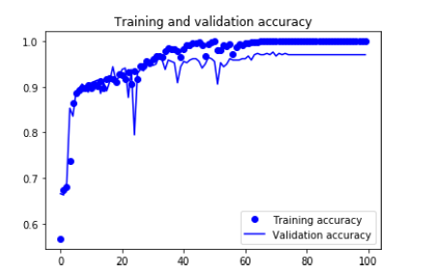

Figure 11: Accuracy Loss Graph for Proposed CNN Model

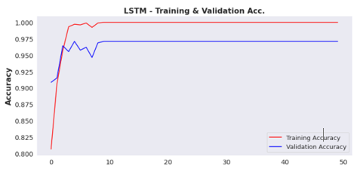

Figure 12 : Accuracy Graph for Proposed LSTM Model

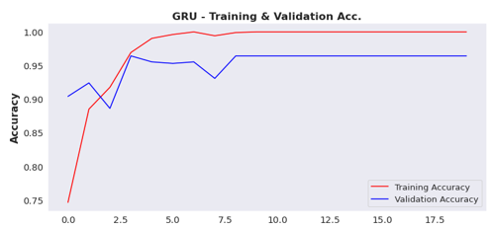

**Figure 13 : Accuracy and Loss Graph for Proposed GRU Model**

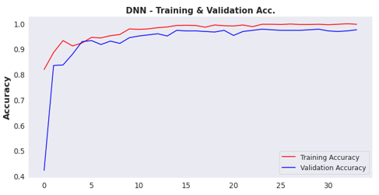

**Figure 14 : Accuracy and Loss Graph for Proposed DNN Model**

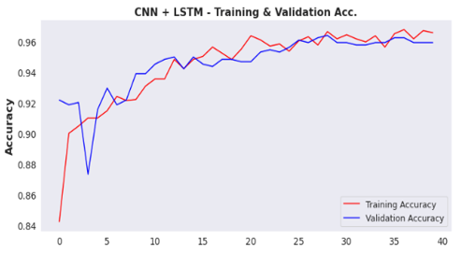

Figure 15 : Accuracy and Loss Graph for Proposed CNN+LSTM Model

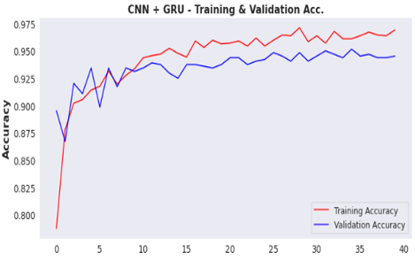

**Figure 16 : Accuracy Graph for Proposed CNN+GRU Model**

Table 2: Number of Layers and Accuracy Score

**for the Proposed DL Models**

|  |  |  |
| --- | --- | --- |
| **Models** | **#Layers** | **Accuracy** |
| CNN | **10** | **97.65%** |
| LSTM | 4 | 96.87% |
| GRU | 4 | 95.46% |
| **DNN** | **17** | **97.94%** |
| CNN+LSTM | 7 | 95.93% |
| CNN+GRU | 7 | 94.53% |

**Figure 1 : The international 10/20 electrode placement system**

